**Airbnb Property Owners Sucking Up Canada's Housing**

**Supply: Report**

08/08/2017 14:59 EDT | Updated 08/09/2017 15:34 EDT

There's been a 50-per-cent spike in short-term rental properties

in the space of a year.

Canadian Press

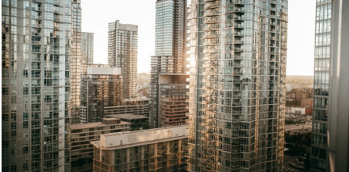

Getty Images/iStockphoto

Condos near Toronto's waterfront. A new report from McGill University says a small group of

owners are dominating Airbnb, and are eating up the supply of housing in Canada's largest

cities.

MONTREAL — New research suggests a small number of large commercial property owners

are the most successful on Airbnb and are eating up the local supply of housing in Canada's

three largest cities in the process.

A team of urban planners from McGill University looked at Airbnb trends in Montreal,

Vancouver and Toronto and noted a 50 per cent increase in the number of short-term rental

properties year over year.

Using figures from an analytics firm, lead author David Wachsmuth says his team found that 10

percent of hosts account for the lion's share of yearly revenue in the three Canadian cities.

The study, which is entitled "Short-term Cities: Airbnb's Impact on Canadian Housing Markets,"

is to be published later today.

Airbnb is calling the McGill study baseless and says data was manipulated to misrepresent the

½ profile of Airbnb hosts.

A spokeswoman says 80 per cent of its users engage in short-term rentals of their primary

residence to earn additional money.

Wachsmuth says he doesn't dispute those figures, but says they are misleading,

"We found two big things: the first is that there has been a very significant concentration of

Airbnb activity — both in terms of what bookings are occurring and who is making money —

among a very small set of hosts," Wachsmuth said Tuesday.

"What we found is that just 10 percent of hosts are accounting for a majority of the revenue

(50 per cent) that's being earned on Airbnb across the three cities. And that concentration is

increasing."